Fenwick Agricultural Show
Established 1864
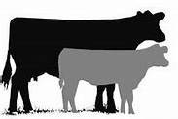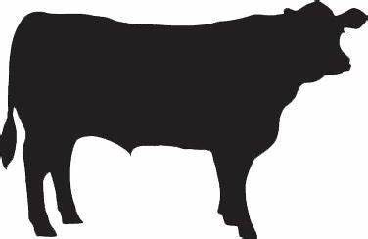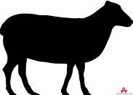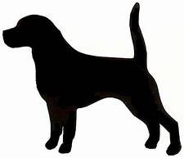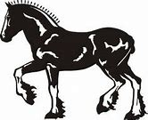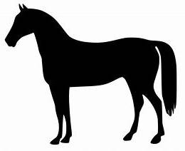
www.fenwickagriculturalshow.co.uk

AITKENHEAD FARM, FENWICK KA3 6BX

SATURDAY 20th JULY 2024

DOGGIE DASH: 10.30-11.00am : DOG SHOW: 11.00am

JUDGE: Ms Sharon MacLean, Stevenston
STEWARD: Joanne Ramsay
ENTRY FEE: £1.00
Entries will be taken at Dog Ring at 10.00 am
ROSETTES: 1st - 5th place
Judging will commence at 11.00 am
-------------------------------------------------------------------------------------------

Pet Classes – 11.00 am approx

1. Musical Sits
2. Dog the judge would most like to take home
3. Best Rescue dog
4. Best Trick
5. Best cross-bred dog or bitch
6. Dress – owner dress up optional!
Best Novelty will now be judged from Classes 1 – 6

7. Junior handler (under 12 years)
8. Junior handler (12 – 18 years)
9. Any variety puppy (6-12 months)
10. Any variety open dog
11. Any Fancy variety open bitch
12. Any variety veteran (7 years +)
Best in Show will now be judged from Classes 9 – 12
************************************
North Glassock Kennels, Fenwick : Gibb of Galston
Alfie’s Leads, Kilmarnock : Petcayr, Ayr
Ayrshire Dog Training, Fenwick
Aiket Boarding Kennels, DunLOP

