  Fenwick Farmers' Society  Established 1864  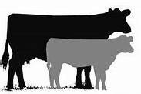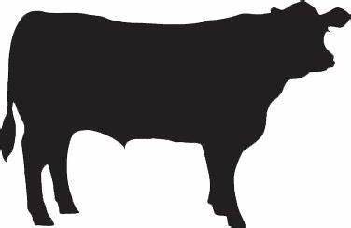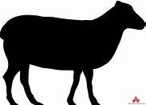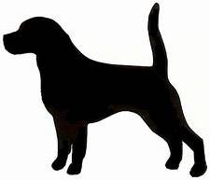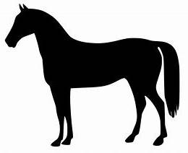 | PAID: Yes/No
 | Cash/Cheque/Bacs
www.fenwickagriculturalshow.co.uk

SATURDAY 20th JULY 2024
AITKENHEAD FARM, FENWICK KA3 6BX
LIGHT HORSE JUMPING ENTRY FORM

EQUINE FLU: It is advised that all competitors have up-to-date vaccinations and Bio security measures should be followed.
No unattended tying up of ponies. Please use common sense.

SEC  USE | CLASS  NUMBER | NAME OF HORSE  OR PONY | HEIGHT | AGE | SEX | NAME OF RIDER | AGE | ENTRY FEE

Entry Fees: £8.00 per class (no late entry fee ) First Aid cover £2 per Rider/Handler

Postal entries close on Wednesday 17th July 2024 TOTAL
Account No: 00330578 Sort code: 80 08 53 Ref: Name + LH Fenwick Show
Entries with cheque payments must be received by Monday 15th July
Please make cheques payable to: Fenwick Agricultural Show

*Name ………………………………………………………………..……

*Address ………………………………………………………………….. *email ……………………………….……………………....

………………………………………………. *Post Code……………… *Tel/Mob No: ………………………………..……………………...

*must be provided – * I consent/do not consent to my details being published. Email will be used for direct contact only.

* Delete as appropriate

Postal Entries by closing date to: Mr Jordan Crowe, Meadowhead Farm, Fenwick KA3 6JJ
DISCLAIMER: Please note, in the event of an accident or injury, the person involved must be attended by the First Aiders on site, in the first instance. Should such an assessment be refused, the Society will not accept or be held responsible for any injury or condition which it is later claimed arose from an incident at the Show. Should an assessment deem it necessary, medical help or the appropriate emergency service will be contacted.

PLEASE ENSURE TROPHIES ARE RETURNED NO LATER THAN 6TH JULY

