  Fenwick Farmers' Society  Established 1864  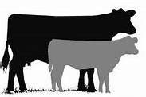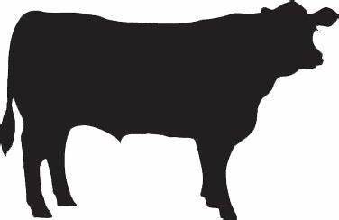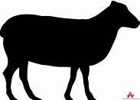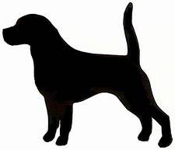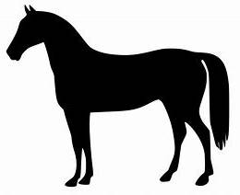 | PAID: Yes/No
 | Cash/Cheque/Bacs
www.fenwickagriculturalshow.co.uk

SATURDAY 20th JULY 2024
AITKENHEAD FARM, FENWICK KA3 6BX
LIGHT HORSE SHOWING ENTRY FORM

EQUINE FLU: It is advised that all competitors have up-to-date vaccinations and Bio security measures should be followed.
No unattended tying up of ponies. Please use common sense.

SEC  USE | CLASS  NUMBER | NAME OF HORSE  OR PONY | HEIGHT | AGE | SEX | NAME OF RIDER | AGE | ENTRY FEE

Entry Fees: £8.00 per class (no late entry fee ) First Aid cover £2 per Rider/Handler

Postal entries close on Wednesday 17th July 2024 TOTAL
Account No: 00330578 Sort code: 80 08 53 Ref: Name + LH Fenwick Show
Entries with cheque payments must be received by Monday 15th July
Please make cheques payable to: Fenwick Agricultural Show

*Name ………………………………………………………………..……

*Address ………………………………………………………………….. *email ……………………………….……………………....

………………………………………………. *Post Code……………… *Tel/Mob No: ………………………………..……………………...

*must be provided – * I consent/do not consent to my details being published. Email will be used for direct contact only.

* Delete as appropriate

Postal Entries by closing date to: Mr Jordan Crowe, Meadowhead Farm, Fenwick KA3 6JJ

PLEASE ENSURE TROPHIES ARE RETURNED NO LATER THAN 6TH JULY

