 |   PAID: | YES/NO |  |  |  | PAID: | YES/NO
Fenwick Farmers' Society  Established 1864  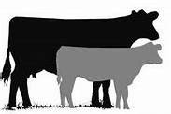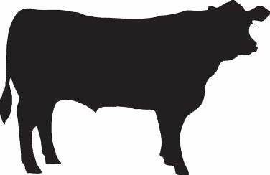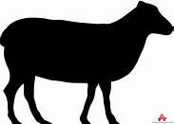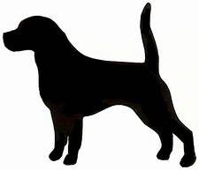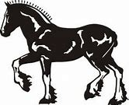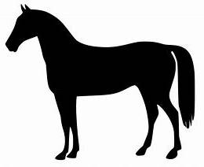  ENTRY FORM FOR CATTLE, SHEEP, DONKEYS AND CLYDESDALES  BVD: All cattle must be from a negative status herd or have been individually tested negative for the BVD virus. Exhibitors must confirm at the entry point to the Showfield  that they have a valid certificate for every animal they wish to exhibit, which must be produced to the steward for checking prior to any animal being unloaded.  NAME OF EXHIBITOR:  ADDRESS:  Post Code:  Email: *  Tel:  * I consent/do not consent to my personal details being published.  Email will be used for direct contact only.  MEMBERSHIP FEE £3.00  ENTER ON THE DAY  or  BY POST TO: MRS M SPEIRS, 25 MURE AVE, KILMARNOCK KA3 1UH  www.fenwickagriculturalshow.co.uk  PLEASE ENSURE TROPHIES ARE RETURNED ON OR  BEFORE THE DAY OF THE SHOW |  |  |  |  | Fenwick Farmers' Society  Established 1864  ENTRY FORM FOR CATTLE, SHEEP, DONKEYS AND CLYDESDALES  BVD: All cattle must be from a negative status herd or have been individually tested negative for the BVD virus. Exhibitors must confirm at the entry point to the Showfield  that they have a valid certificate for every animal they wish to exhibit, which must be produced to the steward for checking prior to any animal being unloaded.  NAME OF EXHIBITOR:  ADDRESS:  Post Code:  Email: *  Tel:  * I consent/do not consent to my personal details being published.  Email will be used for direct contact only.  MEMBERSHIP FEE £3.00  ENTER ON THE DAY  or  BY POST TO: MRS M SPEIRS, 25 MURE AVE, KILMARNOCK KA3 1UH  www.fenwickagriculturalshow.co.uk  PLEASE ENSURE TROPHIES ARE RETURNED ON OR  BEFORE THE DAY OF THE SHOW
  SECTION | CLASS NO | NO OF ENTRIES | TOTAL
  TOTAL
  SECTION | CLASS NO | NO OF ENTRIES | TOTAL
  TOTAL

